URL: <https://www.leeds.ac.uk/about>

[University of Leeds homepage](https://www.leeds.ac.uk/)

Bottom of Form

* [**Home**](https://www.leeds.ac.uk/)
* **Study**
* [**Research and innovation**](https://www.leeds.ac.uk/research-and-innovation)
* [**Business and partnerships**](https://www.leeds.ac.uk/business-partnerships)
* [**Global**](https://www.leeds.ac.uk/global)
* [**Around campus**](https://www.leeds.ac.uk/around-campus)
* [**Give to Leeds**](https://www.leeds.ac.uk/give-to-leeds)
* [**About**](https://www.leeds.ac.uk/about)

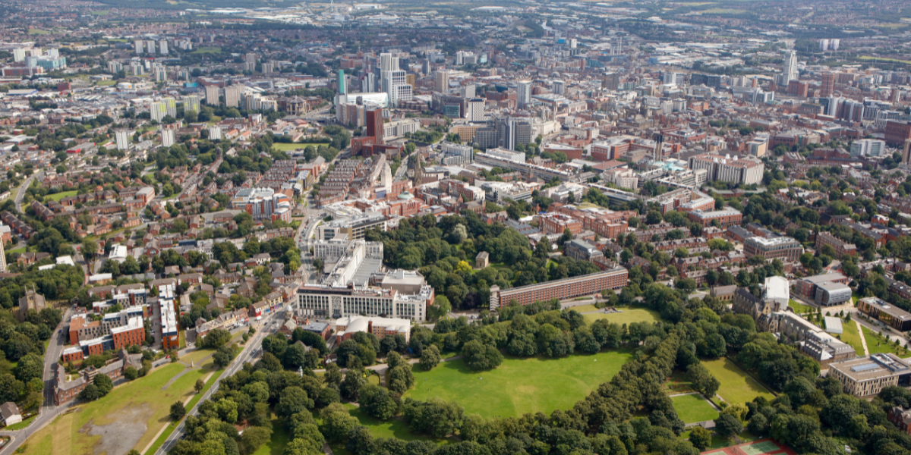

Our campus is a short walk from Leeds City Centre.

[**How to get to the University**](https://www.leeds.ac.uk/about/doc/find-us)

**About**

* [Overview](https://www.leeds.ac.uk/about)
* [Term dates](https://www.leeds.ac.uk/term-dates)
* Structure and governance
* [Find us](https://www.leeds.ac.uk/about/doc/find-us)
* [Our history](https://www.leeds.ac.uk/about/doc/about-history)
* [Contact us](https://www.leeds.ac.uk/about/doc/about-contact-us)
* [Our strategies and values](https://www.leeds.ac.uk/about/doc/strategies-values)

**About the University of Leeds**

Established in 1904, the University of Leeds is one of the largest universities in the UK. We’re part of the Russell Group of research-intensive universities and are renowned globally for the quality of our research and teaching.

* [**Our courses**](https://courses.leeds.ac.uk/)

Search our undergraduate courses, Masters and research degrees.



* [**University strategy**](https://spotlight.leeds.ac.uk/strategy/)

Read our academic strategy for 2020–2030.

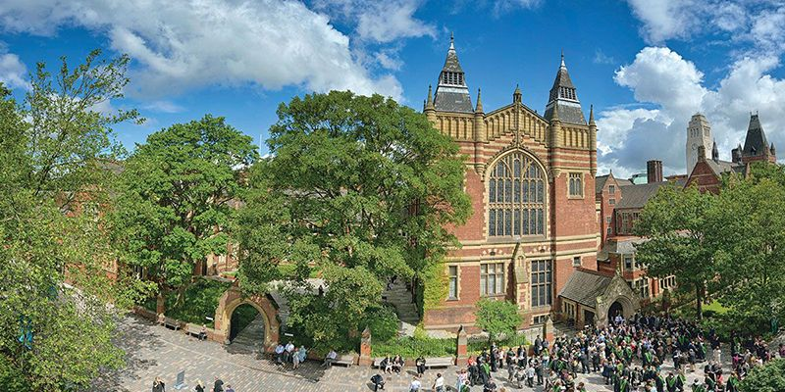

* [**Faculties**](https://www.leeds.ac.uk/about/doc/faculties-contacts)

Find contact details and staff lists for our seven faculties.

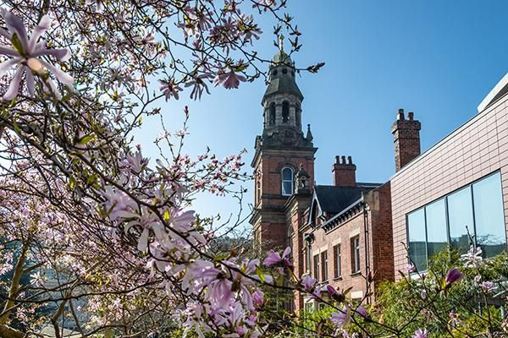

* [**Contact us**](https://www.leeds.ac.uk/about/doc/about-contact-us)

Find key contact details for the University of Leeds.



**Facts and figures**

**Top 100**We’re ranked in the top 100 universities in the world

QS World University Rankings 2025

**29**Our staff have been awarded 29 National Teaching Fellowships

**39,800**More than 39,800 students are currently studying here

**£1.3 billion**We contribute £1.3 billion every year to the UK economy

**Three**We’ve won the Queen’s Anniversary prize three times

**Commendation**For our enhancement of student learning opportunities

Quality Assurance Agency

**Study and courses**

* [Undergraduate](https://www.leeds.ac.uk/undergraduate)
* [Masters courses](https://www.leeds.ac.uk/masters)
* [Research degrees](https://www.leeds.ac.uk/research-degrees)
* [International](https://www.leeds.ac.uk/international-students)
* [Course Search](https://courses.leeds.ac.uk/)

**About Us**

* [Campus map](https://www.leeds.ac.uk/campusmap)
* [Our history](https://www.leeds.ac.uk/about/doc/about-history)
* [Faculties](https://www.leeds.ac.uk/about/doc/faculties-contacts)
* [Governance](https://www.leeds.ac.uk/structure-governance/doc/governance)
* [Reports, accounts and policies](https://www.leeds.ac.uk/structure-governance/doc/reports-accounts-policies)
* [Strategies and values](https://www.leeds.ac.uk/about/doc/strategies-values)
* [Equality](https://equality.leeds.ac.uk/)
* [Executive team](https://www.leeds.ac.uk/university-executive)
* [News](https://www.leeds.ac.uk/news/)
* [Events](https://www.leeds.ac.uk/events/)

**Quicklinks and contacts**

* [Jobs](https://www.leeds.ac.uk/university-jobs)
* [Term dates](https://www.leeds.ac.uk/term-dates)
* [Services A-Z](https://forstaff.leeds.ac.uk/forstaff/homepage/375/services)
* [Library](https://library.leeds.ac.uk/)
* [Alumni](https://www.leeds.ac.uk/alumni)
* [Media relations](https://www.leeds.ac.uk/media-relations)
* [VideoLeeds](https://mymedia.leeds.ac.uk/)
* [Staff A-Z](https://www.leeds.ac.uk/staffaz)
* [Contacts](https://www.leeds.ac.uk/about/doc/about-contact-us)
* [Leeds University Union](https://www.luu.org.uk/)

**Contact information**

**University of Leeds**

Woodhouse Lane

LeedsWest YorkshireLS2 9JTUnited Kingdom

**Site information**

* [Privacy](https://www.leeds.ac.uk/privacy)
* [Accessibility](https://www.leeds.ac.uk/about/doc/accessibility-statement)
* [Terms & conditions](https://www.leeds.ac.uk/termsandconditions)
* [Freedom of information](https://www.leeds.ac.uk/freedom-of-information)
* [Modern slavery statement](https://www.leeds.ac.uk/about/doc/modern-slavery-annual-statement)

[Skip to main content](https://equality.leeds.ac.uk/#main)

UNIVERSITY LINKS

[University of Leeds logo](https://www.leeds.ac.uk/)

Search

[Equality and Inclusion Unit](https://equality.leeds.ac.uk/)

* [HOME](https://equality.leeds.ac.uk/)
* [ABOUT](https://equality.leeds.ac.uk/about/)
* [EVENTS & NEWS](https://equality.leeds.ac.uk/events-news/)
* [GOVERNANCE, STRATEGY AND POLICY](https://equality.leeds.ac.uk/governance_strategy_policy/)
* [EQUALITY DATA](https://equality.leeds.ac.uk/equality-data/)
* [SUPPORT & RESOURCES](https://equality.leeds.ac.uk/support-and-resources/)
* [JOBS](https://equality.leeds.ac.uk/job-vacancies-within-the-equality-policy-unit/)
* [STAFF NETWORKS](https://equality.leeds.ac.uk/staff-networks/)
* [EDI TRAINING](https://equality.leeds.ac.uk/equality-inclusion-module/)

Equality and Inclusion Calendar 2023 - 24

The calendar highlights key diversity days, including the main faith days observed or celebrated, awareness dates, public holidays and important dates for the University.

[MORE](https://equality.leeds.ac.uk/support-and-resources/equality-and-inclusion-calendar-2023-24/)

Previous slideNext slide

E&I CALENDAR 2023-24EDI IMPLEMENTATION PLANEDI GOVERNANCE

Item 1 of 3

Equality & Inclusion Unit (E&IU)

Contact Us

If you have any queries or questions concerning equality, diversity and inclusion activities, policies or procedures*, the Equality and Inclusion Unit can be contacted by email at [equality@leeds.ac.uk](mailto:equality@leeds.ac.uk).

**\***The Equality and Inclusion Unit can offer advice but does not undertake casework on behalf of individuals.

Key Activities

[Introduction to Equality and Inclusion Training](https://equality.leeds.ac.uk/equality-inclusion-module/)

[Staff and Student Equality Data](https://equality.leeds.ac.uk/equality-data/)

[Equality Related Support & Resources](https://equality.leeds.ac.uk/support-and-resources/)

[Equality and Inclusion Policies and Guidance](https://equality.leeds.ac.uk/governance_strategy_policy/policies/)

[Reporting of Equality Related Incidents](https://equality.leeds.ac.uk/reporting-of-equality-related-incidents/)

[Staff Networks](https://equality.leeds.ac.uk/staff-networks/)

News

[Celebrating International Women's Day 2024](https://equality.leeds.ac.uk/news/celebrating-international-womens-day-2024/)

Colleagues and students are warmly invited to help mark and celebrate International Women's Day at the University of Leeds. The theme of the UN's International Women's Day 2024 is Invest in Women: Accelerate Progress. Under Your Nose: International Women's Day Event The Women at Leeds Staff Equity network and Leeds Trinity University Women's Network are...

MONDAY 4 MARCH, 2024

[Celebrating LGBT+ History Month 2024](https://equality.leeds.ac.uk/news/celebrating-lgbt-history-month-2024/)

Colleagues, students and members of the public are warmly invited to help mark and celebrate LGBT+ History Month at the University of Leeds. Professor Paul Johnson OBE, Executive Dean of the Faculty of Social Sciences and University Executive Group LGBT+ Equity Champion said: “LGBT+ History Month is for everyone, and I hope everyone in our...

MONDAY 12 FEBRUARY, 2024

[Race Equality Charter Launch](https://equality.leeds.ac.uk/news/race-equality-charter-launch/)

The University has reaffirmed its clear intent to be an anti-racist institution, starting a comprehensive programme of activity to create greater race equity at an event held on 10 October hosted by Dr Kendi Guantai, Associate Professor & University Dean for Equity, Diversity, and Inclusion (EDI). Author, philosopher, social justice and human rights advocate-activist, educator...

WEDNESDAY 11 OCTOBER, 2023

[VIEW ALL NEWS](https://equality.leeds.ac.uk/news/)

Accreditations

Social media links

[Twitter](https://twitter.com/LeedsEquality)

Site information

© 2024 University of Leeds, Leeds, LS2 9JT